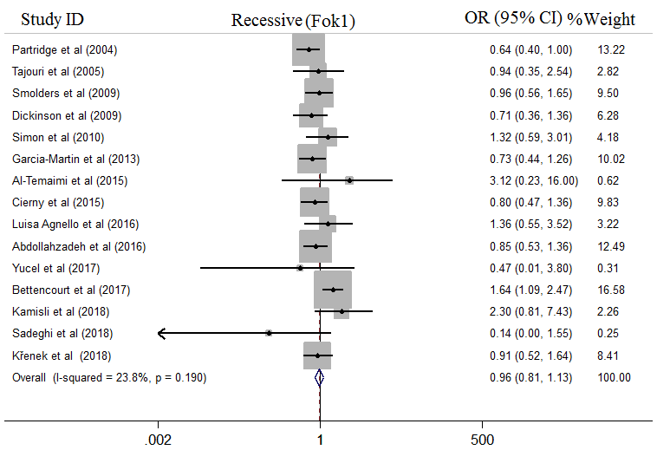
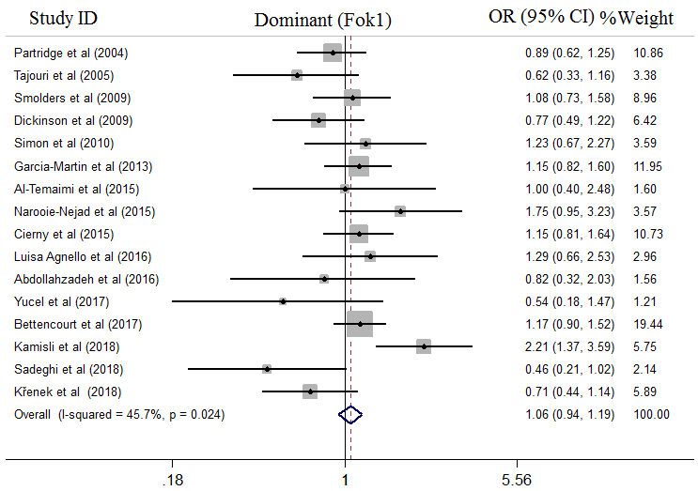

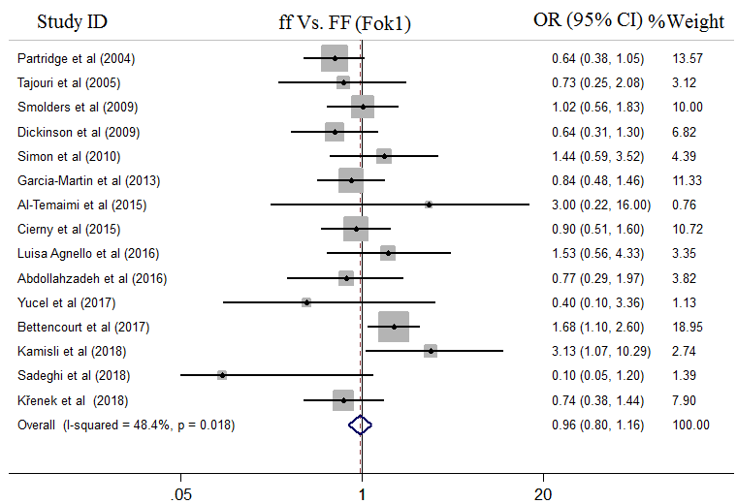
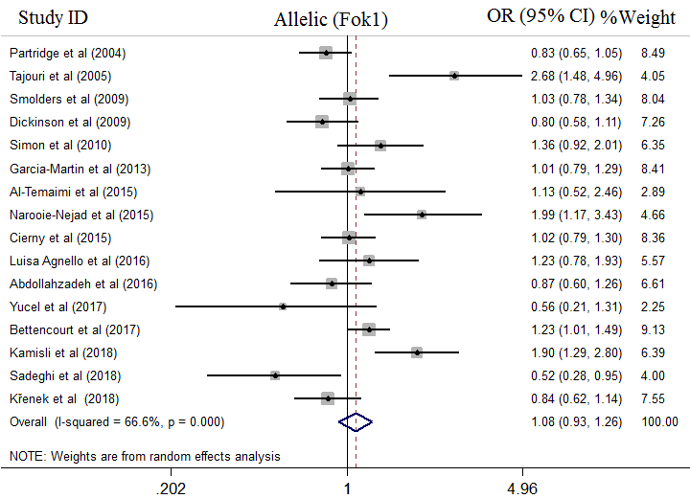

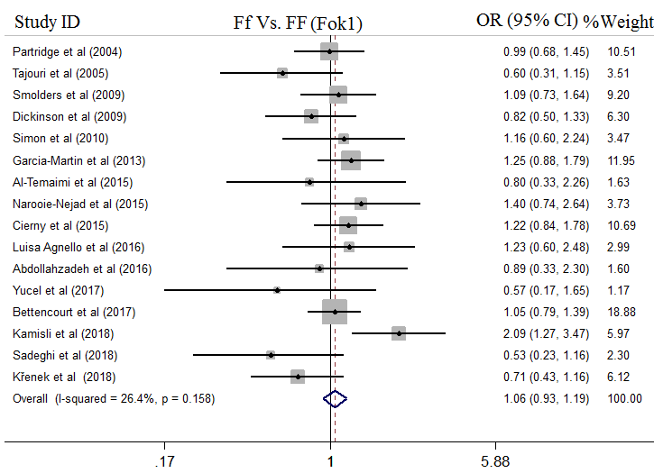

Figure 1. Forest plot of association between FokI gene Polymorphism and MS risk; Dominant model, Recessive model ,allelic model, ff VS. FF model, Ff vs FF model.

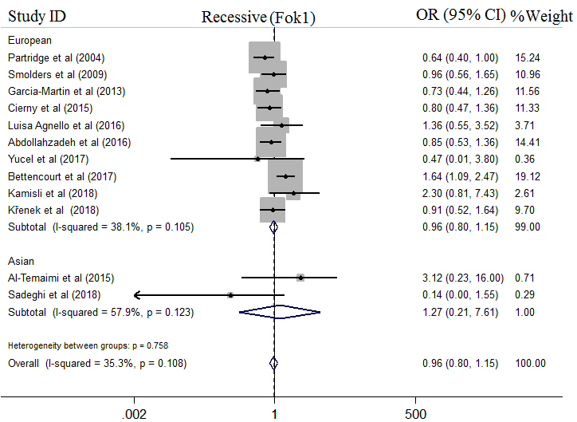
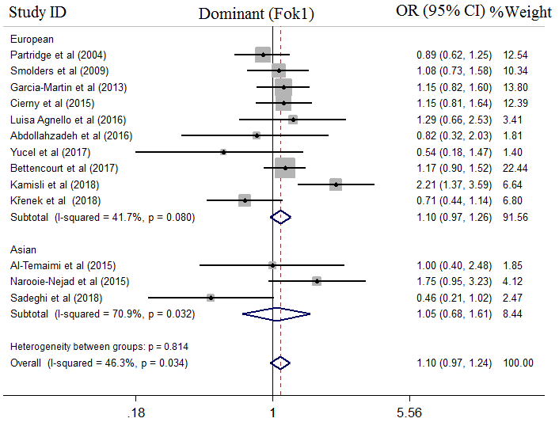

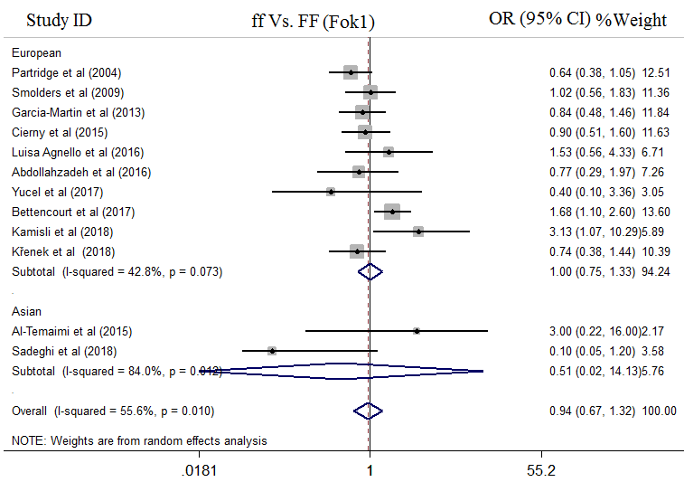
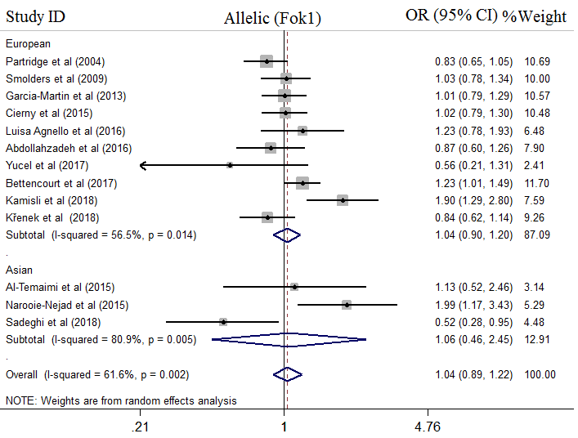

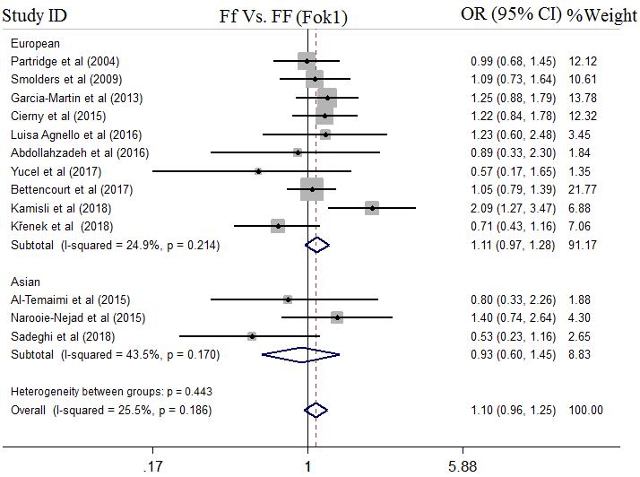

Figure 2. Forest plot of pooled odds ratio (OR) ) and 95% confidence interval of individual studies and pooled data for the association between FokI polymorphism and MS risk in different ethnicity subgroups and overall populations for Dominant model, Recessive model, allelic model, ff VS. FF model, Ff vs FF model.

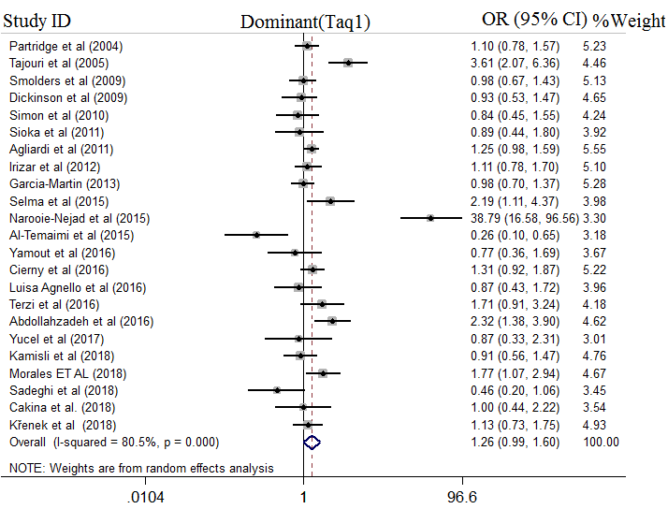
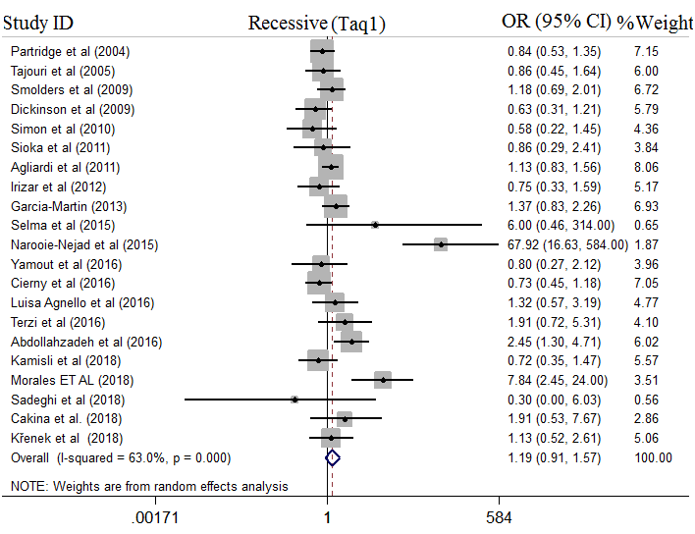
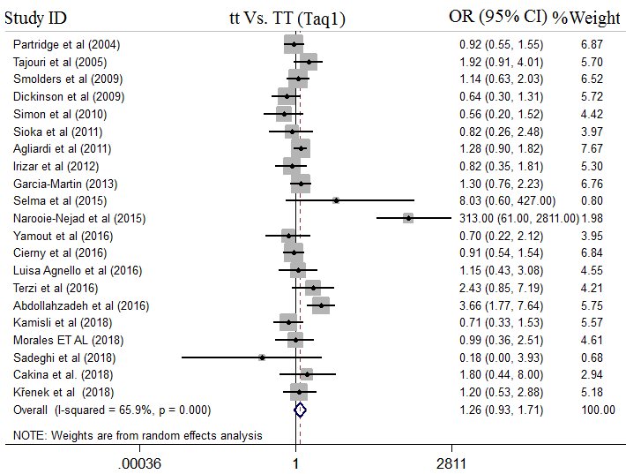
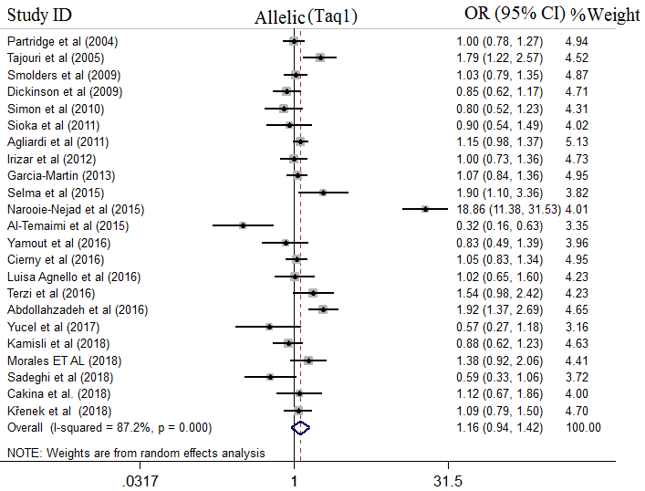

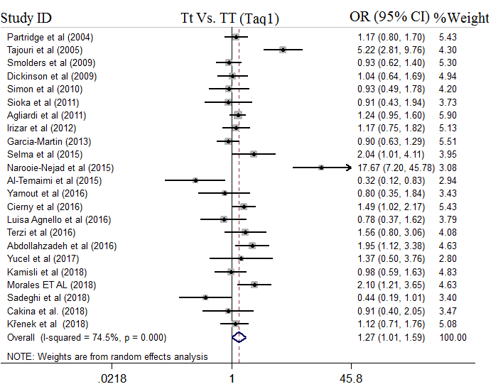
Figure 3. Forest plot of association between TaqI gene Polymorphism and MS risk; Dominant model, Recessive model, allelic model, tt VS. TT model, Tt vs TT model.

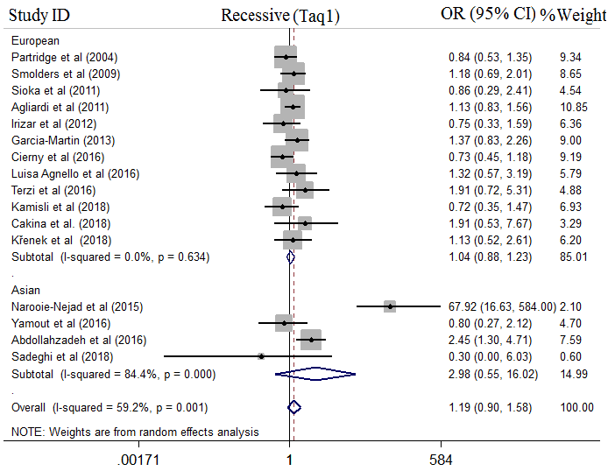
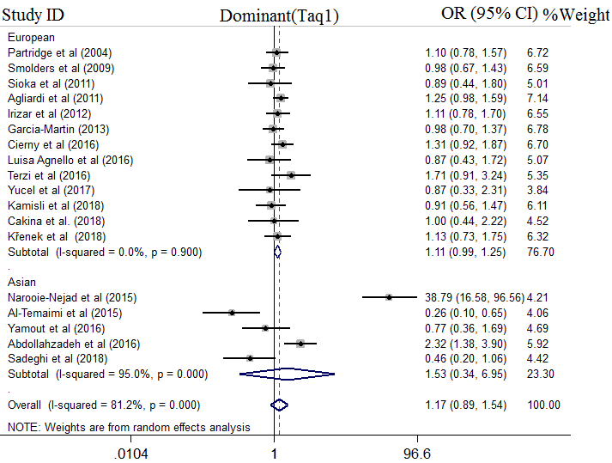

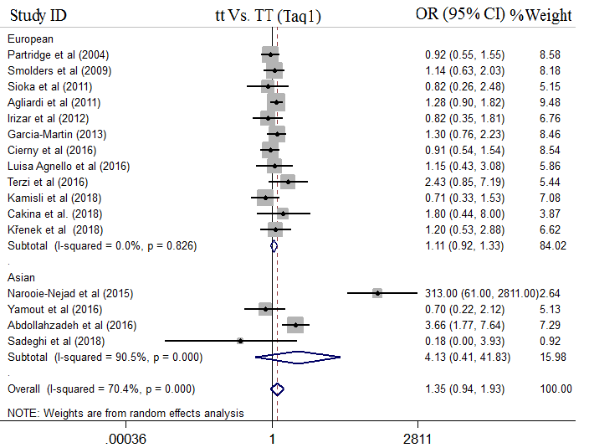
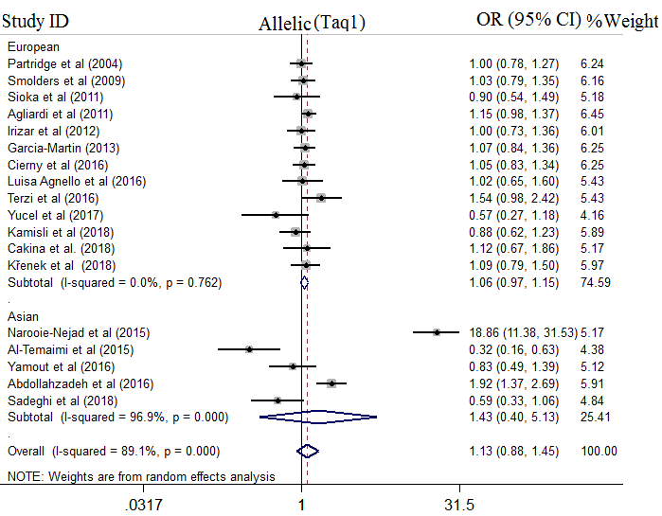

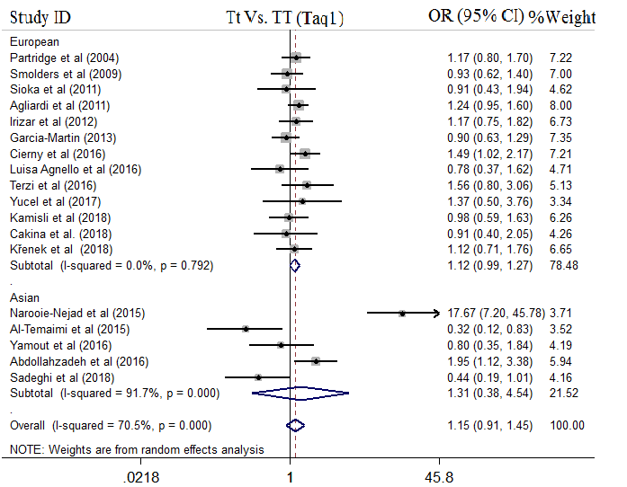

Figure 4. Forest plot of pooled odds ratio (OR) ) and 95% confidence interval of individual studies and pooled data for the association between TaqI polymorphism and MS risk in different ethnicity subgroups and overall populations for Dominant model, Recessive model, allelic model, tt vs TT model, Tt vs TT model.

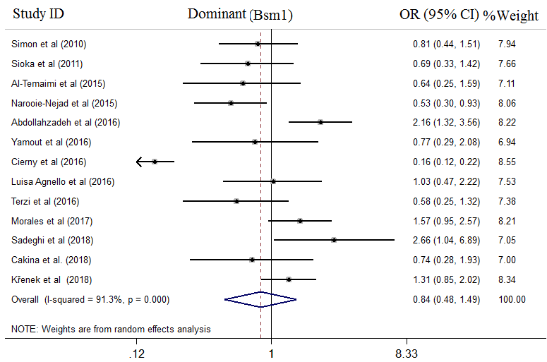
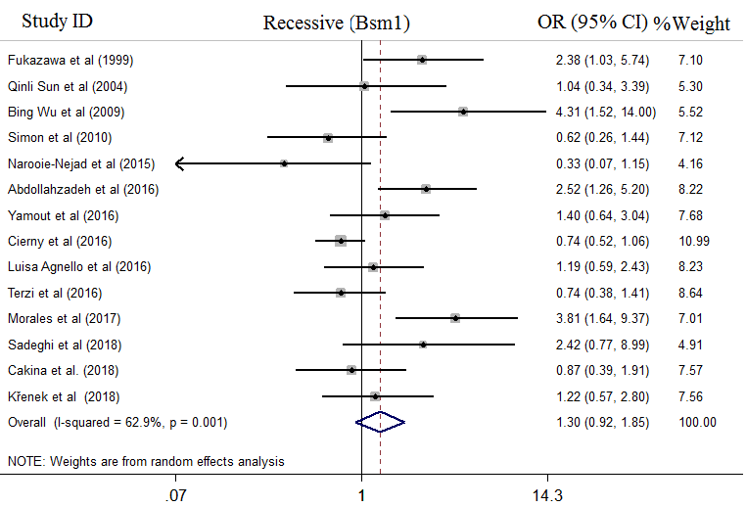

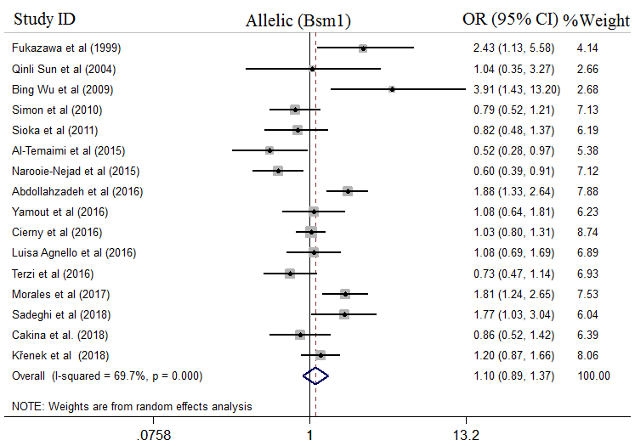
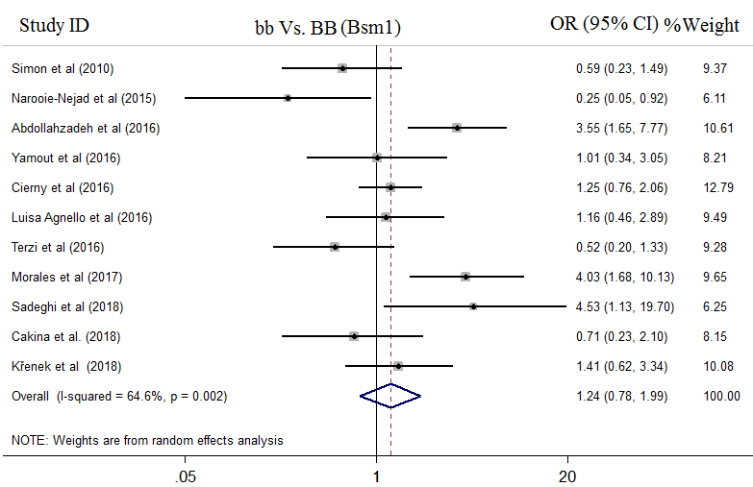

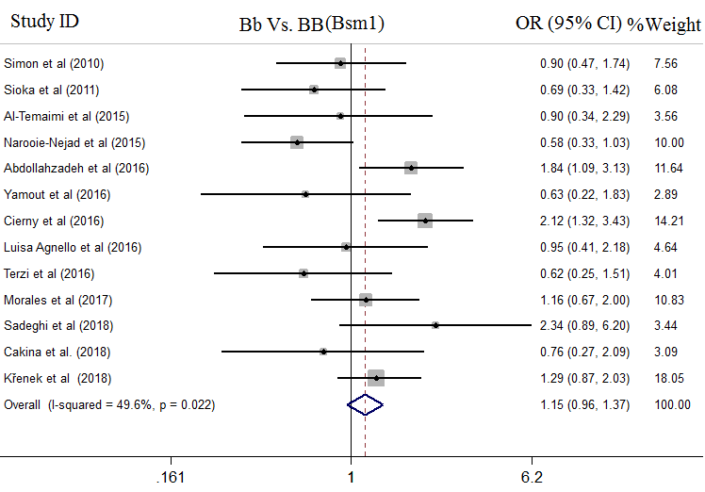

Figure 5. Forest plot of association between BsmI gene Polymorphism and MS risk; Dominant model, Recessive model, allelic model, bb VS. BB model, Bb vs BB model.

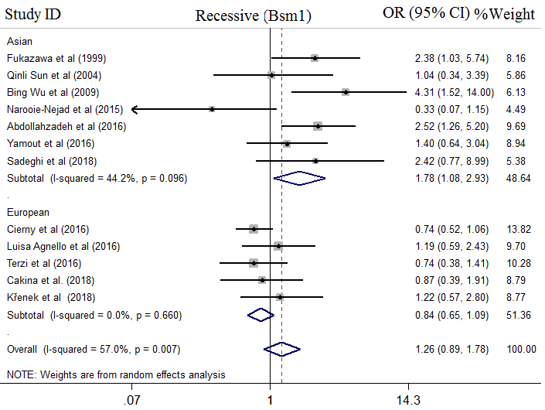
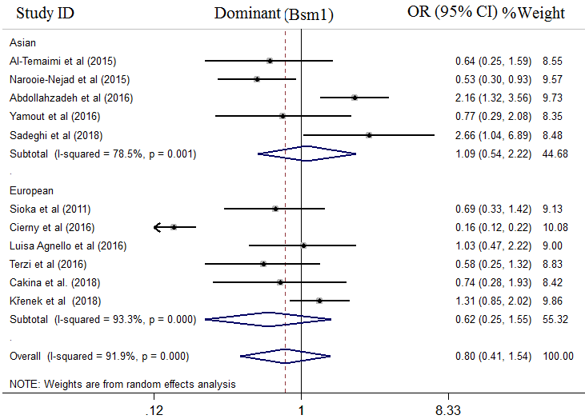

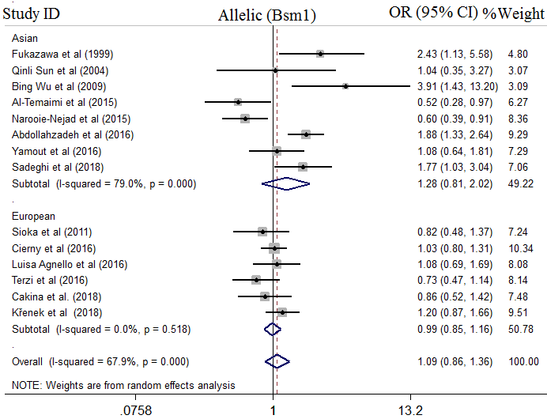
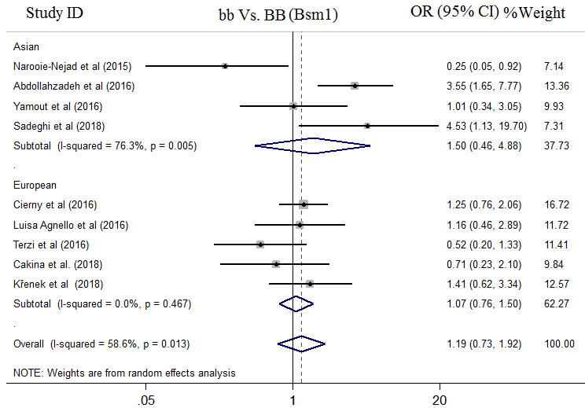

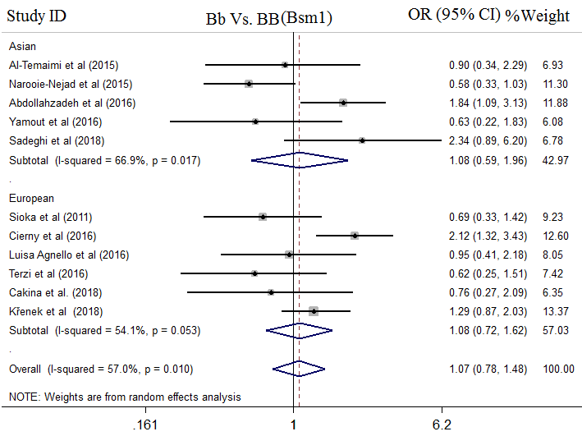

Figure 6 . Forest plot of pooled odds ratio (OR) ) and 95% confidence interval of individual studies and pooled data for the association between BsmIpolymorphism and MS risk in different ethnicity subgroups and overall populations for Dominant model, Recessive model allelic model, bb VS. BB model, Bb vs BB model.

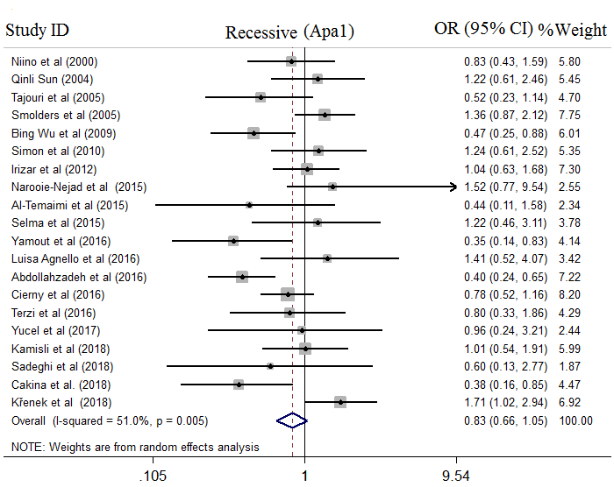
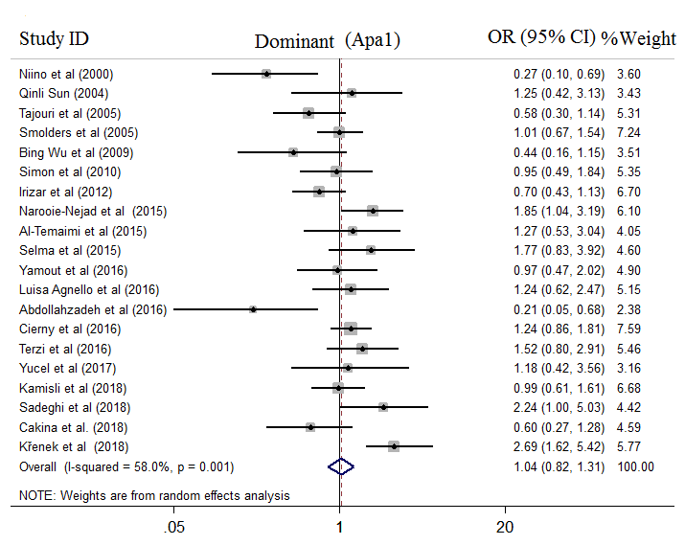

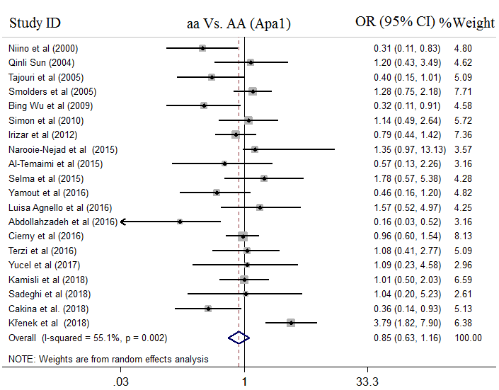
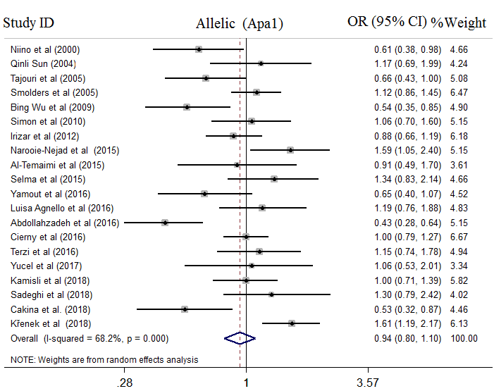

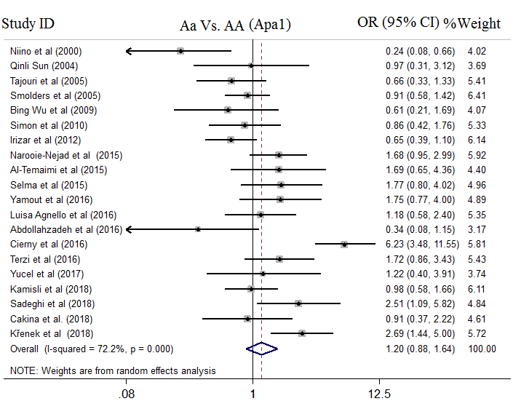

Figure 7. Forest plot of association between ApaI gene Polymorphism and MS risk; Dominant model, Recessive model, allelic model, aa VS. AA model, Aa vs AA model.

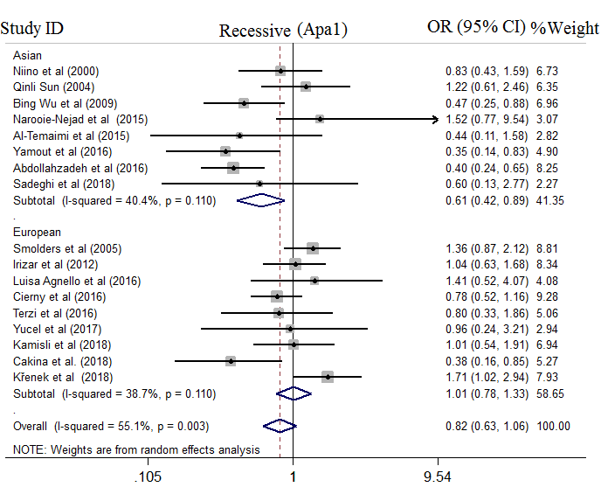
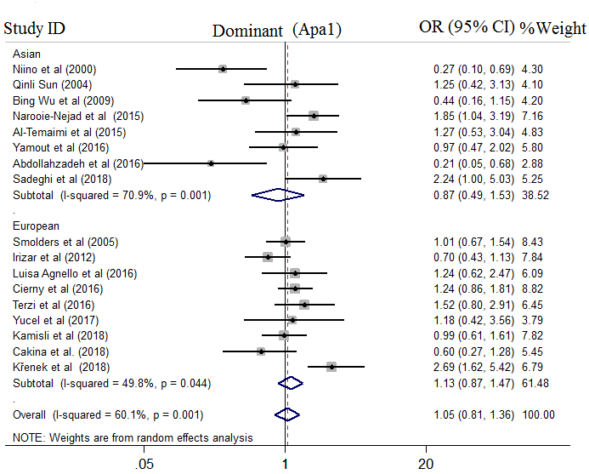

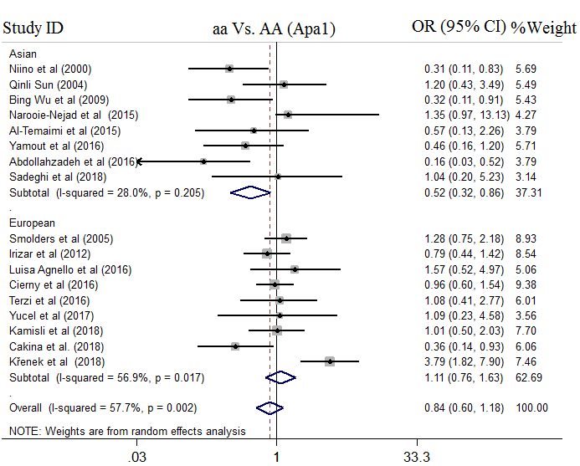
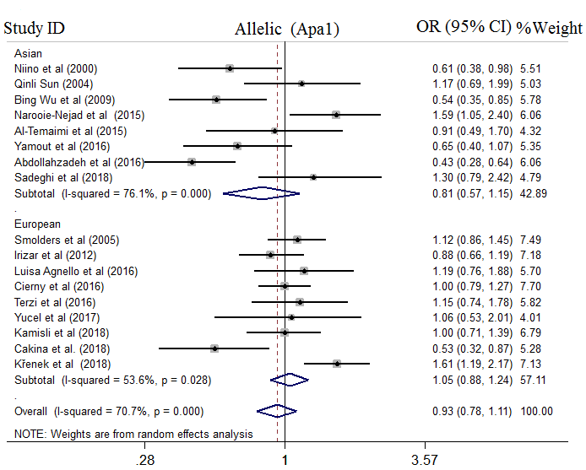

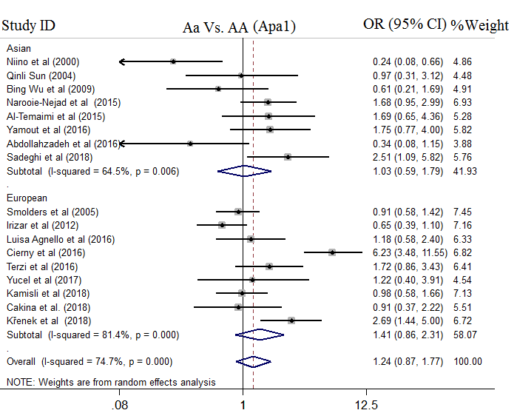

Figure 8. Forest plot of pooled odds ratio (OR) ) and 95% confidence interval of individual studies and pooled data for the association between ApaI polymorphism and MS risk in different ethnicity subgroups and overall populations for Dominant model, Recessive model, allelic model, aa VS. AA model, Aa vs AA model.

